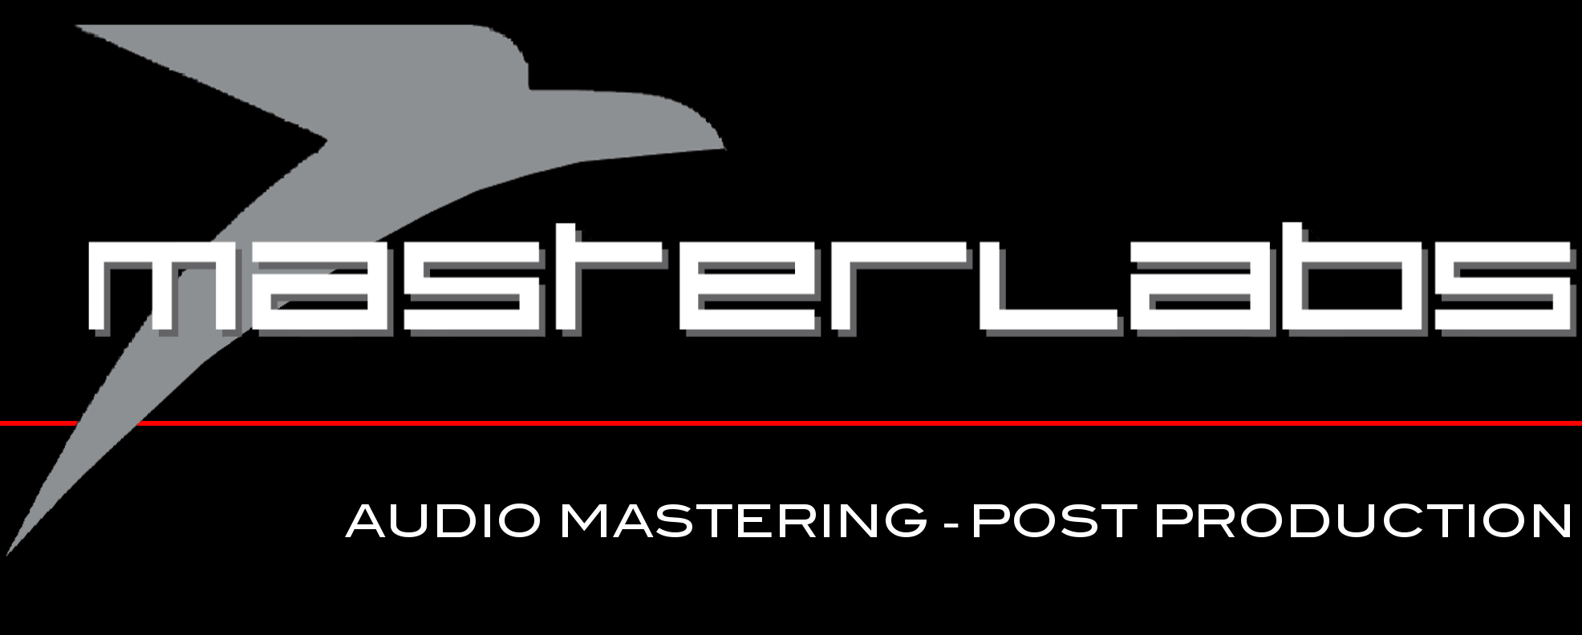

PLEASE SAVE THIS FORM WITH THE PRODUCTION TITLE, AND UPLOAD WITH YOUR AUDIO TO https://www.hightail.com/u/Masterlabs

PRODUCTION | PRODUCTION TITLE | ARTIST NAME | RECORD LABEL /  CAT NUMBER | CONTACT NAME/NUMBER
Album

DELIVERY FILE FORMAT | OUTPUT FILE FORMAT | INVOICE DETAILS | DATE IN
WAV | DDP/WAV/PMCD/VINYL

TRACK | TRACK TITLE | FILE TITLE | DURATION | ISRC
1 |  |  | :
2 |  |  | :
3 |  |  | :
4 |  |  | :
5 |  |  | :
6 |  |  | :
7 |  |  | :
8 |  |  | :
9 |  |  | :
10 |  |  | :
11 |  |  | :
12 |  |  | :
13 |  |  | :
14 |  |  | :
15 |  |  | :

Notes to engineer & references:

Leave aprox -1 dBfs > -3 dBfs headroom on your final mix.
Keep the 2 track buss brick wall limiting to a minimum for our copy.
Leave at least a one second ‘handle’ at the' top & tail' of each mix
Double check all the final mixes you send us making sure they are the correct versions of the mixes

Save this form with either your catalogue number or artist name , before emailing it to us
The CD Data Base (CDDB or Gracenote database) is an internet-based database that collects and distributes information about CD’s. This is the information that you can see on iTunes and other software. The user has to upload this information and it is his responsibility to verify if everything is correctly provided. Therefore, everything will appear exactly as you intend it to and will be shared with other users of the database. It can include much more information than artist, album, title, etc.

CD TEXT is information encoded at the header of an audio CD that can be used to store basic information such as artist, album, song titles and ISRC codes. This information is used only by players that are CD Text enabled (car stereos, home stereo components that have an LCD display built into them). Computers or iTunes does not use CD Text, so it is definitely not essential to include it on your master. If you are not 100% certain of how you want you song titles to appear, we recommend against encoding CD Text.

IRSC codes are digital signatures that are embedded onto CD’s that allow for the tracking and management of songs in the digital domain. Online music distributors usually require them. If you want them on your CD, you need to provide them to us before your master is finished. It is your responsibility to acquire them.
The PPI provides these codes for Ireland. http://www.ppimusic.ie/

