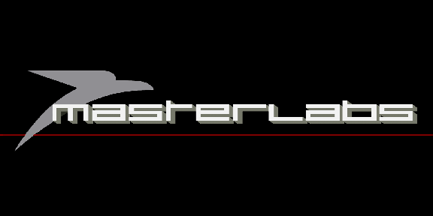

Below we have listed the various specifications you will need to follow in order to supply suitable artwork that will produce high quality print results. Please ensure all artwork for print is supplied in line with these specifications. MLV Record Pressing Ltd cannot accept responsibility for print errors or late deliveries where artwork has been supplied incorrectly.

Paper Parts
Sleeves, Labels, Disco Bags, etc

Dimensions: All artwork should have accurate dimensions, if you are unsure how to prepare accurate templates in the software you are using, please consult someone with experience, or watch the tutorials carefully.

Bleeds and Safety: All artwork should include a bleed of 3 mm on all sides, all text and logos should be at least a further 3 mm from the crop guides, this is because cutting can only be accurate to about 1.5 mm when chopping small items like Vinyl Labels. The easiest way to think of this if you are uncertain is to make sure the background image goes right to the edge of the bleed line and that all text, logos, etc. do not enter the safety areas (both of which are labeled clearly on our templates).

Resolution: All non-vector artwork should be supplied with a resolution of at least 300 dpi as this is the minimum required to achieve a high quality print.

Colour: All colour printing is full colour and should be completed and saved in CMYK.

Ink Coverage: The maximum ink coverage must be no more than 320%, if you are unsure how to check the ink coverage please contact a member of our design team.

Type: All fonts should be embedded or converted to outlines.

Overprint: Normally when two separate colours overlap each other they will knock out, which means they will not print one over the other. Using overprint will ensure that one colour will print over another, i.e. black text on a pale background for example. Overprinting is generally used to avoid the need for trapping and to avoid white gaps between colours in case of misalignment of plates during the print process. Please be aware that if overprinting is used incorrectly we cannot always check for this and it can generate unexpected results.

Formats: Artwork should be supplied as press quality PDFs,

Booklet Pagination: Please supply your booklet artwork as double page spreads correctly paginated. If you are unsure of the order please contact a member of our design team.

Foiling & special finishes: When opting to have a foiling or special finish (i.e. spot UV varnish) this would be best supplied as a vector based image and on a separate layer or file to the rest of the artwork however a rasterised image can work in some circumstances. We would not recommend having the areas for the foiling/varnish too close together as this may result in the areas becoming fused and loosing definition. If you have any questions please contact a member of our design team who would be happy to advise you.

Important Information

We make every effort to ensure that your final product will be of the highest quality. Due to monitors and printers using different methods to display colours, some variations will occur when the designs are transferred from screen to print. The amount of variation will depend on the brightness and contrast settings of your monitor and also the colour calibration facilities available to you.

In most cases a printed proof of the artwork prior to the final run is not a necessity; we have an experienced design team that will check all of your designs very carefully and contact you should they feel that a printed proof is necessary. If you would prefer to see a printed proof we can supply them for an additional fee.

We will be unable to print your designs if they do not meet the requirements listed above. These specifications are in place to guarantee that all of the products produced at MLV will be of the highest quality.

